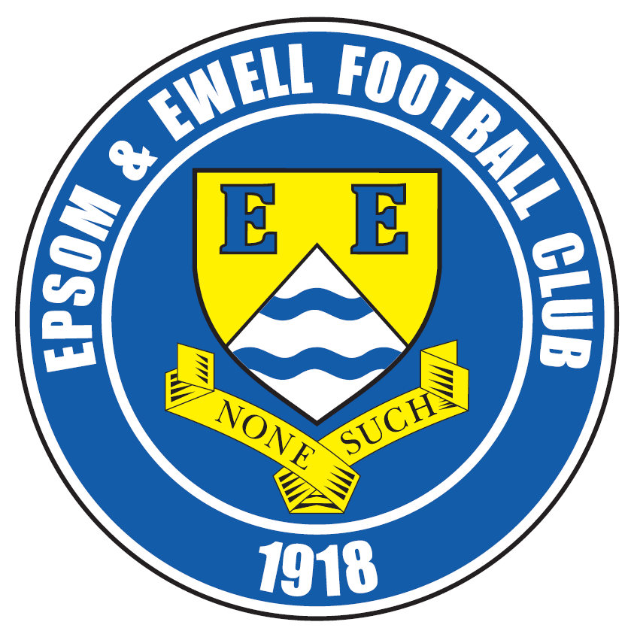 | Epsom & Ewell F.C.  23  v  Knaphill F.C.  Saturday, 12th March 2016
Good afternoon! We welcome the players, supporters and officials of Knaphill for a League match, together with today’s match officials and our own regular supporters.

Last season we won 4-1 at Redding Way and also won a League Cup tie at High Road 2-1 although the visitors scored a last minute winner to take the return match 2-1 in our final home game of the season. This season we drew 1-1 and although we had the majority of chances and possession, a sloppy fifteen minute period gave Knaphill an opportunity and they took it to secure a draw.

Our last appearance here was eleven days ago when Spelthorne Sports were our visitors and it was nice to get back to winning ways after our two home defeats with a 2-1 win. Kyle Hough put us ahead in the 40th minute but they were level before the break. In the second half a superb free kick from Matt Ferdinando won us the points. Unfortunately we will miss his performances for the next four matches, starting today following his sending off against Hartley Wintney.

We then travelled to Chertsey Town last Saturday and won 5-3 in a strange match! We raced into a two goal lead inside five minutes as Bentley Graham and Rob Hendry steered low shots past the shell shocked keeper but from that point the game was more even and by the time Kyle had extended our lead on the half hour it was a bit harsh on the visitors. They did get a goal back just before the break and pushed for more in the second half but two quick goals from Matt Farrell and Matt Ferdinando then gave us a 5-1 lead. Two late goals for the home side were disappointing to concede but the hard work had been done by then. This was the third time this season that we have scored at least five goals away from home in the League. Although we also did that last year with a five in our final match at Frimley Green, this is only the fourth time we’ve achieved this in history (1926/27, 1974/75) so much credit goes to Glyn and the boys.

Following this match we are at home again on Tuesday when Cove visit for a League match. Obviously their non-appearance in December was very frustrating, but it is good to see that they have stabilised and we must be work hard to ensure that we keep on picking up points.

Next Saturday, weather permitting, we travel to Chessington & Hook and then to Farnham on Tuesday before hosting Westfield on the Good Friday. Please note the unusual start time of 1pm.

I am now able to continue producing our programmes again. The reasons for my not being able to do so over the past month are well documented and I apologise here to regular readers who have had to miss out on content as a result of a decision by the Surrey F.A. that we as a club completely disagree with. Hopefully that matter is behind us now and we can all move on.

Enjoy the game!

Rich

You can now follow us on Facebook www.facebook.com/epsomandewellfc or Twitter @EEFCOfficial
and we are now on Instagram too at www.instagram.com/epsomandewellfc

Cover Photos by Gemma Jarman

- A snapshot of many Epsom supporters at Chertsey Town on Saturday
- Jim Dean receives his Super Six cheque from Treasurer Steve Dyke at Chertsey


Cherry Red Records Combined Counties League
Premier Division Table 2015/16
inc Tuesday 8th March | P | W | D | L | F | A | Pts | GD | H | A
Hartley Wintney | 29 | 24 | 2 | 3 | 86 | 28 | 74 | +58 | 0-1 | 3-3
Ashford Town (Mx) | 31 | 22 | 2 | 7 | 83 | 41 | 68 | +42 | 30/4 | 3-2
Epsom & Ewell | 30 | 18 | 8 | 4 | 70 | 32 | 62 | +38 | - | -
Camberley Town | 26 | 17 | 5 | 4 | 50 | 22 | 56 | +28 | 16/4 | 1-1
Horley Town | 29 | 16 | 6 | 7 | 70 | 39 | 54 | +31 | 3-4 | 2-2
Hanworth Villa | 30 | 16 | 3 | 11 | 56 | 44 | 51 | +12 | 5-0 | 23/4
Colliers Wood United | 34 | 15 | 5 | 14 | 69 | 60 | 50 | +9 | 3-1 | 3-0
Raynes Park Vale | 30 | 14 | 2 | 13 | 61 | 58 | 45 | +3 | 3-1 | 28/3
Spelthorne Sports | 33 | 12 | 9 | 12 | 60 | 64 | 45 | -4 | 2-1 | 6-2
Guildford City | 31 | 13 | 6 | 13 | 61 | 67 | 45 | -6 | 4-0 | 2/4
Knaphill | 25 | 13 | 2 | 10 | 56 | 38 | 41 | +18 | - | 1-1
Bedfont Sports | 31 | 11 | 8 | 12 | 52 | 44 | 41 | +8 | 1-0 | 2-2
Windsor | 32 | 11 | 8 | 13 | 56 | 63 | 41 | -7 | 2-2 | 1-2
Sutton Common Rovers | 30 | 11 | 3 | 16 | 52 | 63 | 36 | -11 | 3-1 | 2-1
AFC Hayes | 31 | 10 | 6 | 15 | 45 | 59 | 36 | -14 | 1-1 | 12/4
Farnham Town | 25 | 10 | 4 | 11 | 48 | 43 | 34 | +5 | 1-0 | 22/3
Badshot Lea | 30 | 11 | 1 | 18 | 43 | 77 | 34 | -34 | 9/4 | 1-0
Westfield | 25 | 9 | 6 | 10 | 33 | 43 | 33 | -10 | 25/3 | 0-0
Chertsey Town | 31 | 8 | 7 | 16 | 43 | 57 | 31 | -14 | 0-1 | 5-3
Chessington & Hook | 27 | 7 | 2 | 18 | 42 | 70 | 23 | -28 | 1-0 | 19/3
Redhill | 25 | 3 | 3 | 19 | 30 | 64 | 12 | -34 | 3-0 | 1-0
Cove | 30 | 2 | 1 | 27 | 25 | 115 | 7 | -90 | 15/3 | 7-0

Lucky Day? – 12th March
Played 14 - W 2 D 5 L 7 - F 23 A 35 - PPG 0.79 - Very Poor
We haven’t won on this day since 1932!
Our Club record against today’s opponent
Played 5 - W 3 D 1 L 1 - F 11 A 7 - PPG 2.00 - Very Good
Largest wins and losses against today’s opponent
13th Sept 2014 - (A) W 4-1 - League - 18th April 2015 - (H) L 1-2 - League
Last visit
Saturday 18th April 2015 - L 1-2 - Combined Counties League

Club Manager – Glyn Mandeville
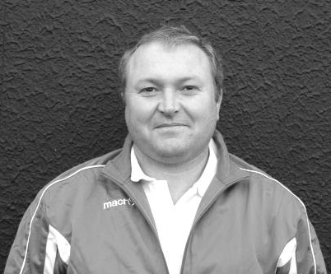
Good afternoon and welcome to High Road for our game against Knaphill.

We come into today's game on the back of two good wins. They weren't the best displays this season but the work rate and desire was there.

Even though we were 5-1 up against Chertsey we still allowed them the odd chance, which the lads have been made to pay for.

It was great to see George Murphy back in the squad even though he didnt get on at Chertsey, but I believe in trying to improve as a squad and when players like George come along its great for us to be able to add quality to what we already have. Also it's great to see the new lads such as Bentley Graham and Elliott Thompson getting on and fitting in so well.

Today's game will be very tough as we saw in the away fixture earlier on this season where the weather played a big part in the quality of football played that day.

Please enjoy the game and have a safe trip home.

Manders

Club Captain - Sam Currie
Good afternoon and welcome to High Road for this afternoon’s game with Knaphill.

After two wins on the bounce we are hopefully preparing to finish the season on a high - accumulating as many points as possible to see where that puts us come the end of the season.

One thing we do know is that we still have some good strong sides to play both here and away from home and we know these points won't come easy - starting against Knaphill today.

We came away from Redding Way earlier in the season a little down with the result, knowing that we should have taken more from the game - but they kept going to the death and we know this will be similar today.

The squad is looking strong at the moment and with the added talents of Elliott and Bentley - and the right preparation to each game - we have the capabilities in house, it's just bringing it all together!


We hope you have an enjoyable afternoon and we wish all the Knaphill fans a safe journey home after the game.

All the best and thank you for your continued support as always.

Sam

Latest Results and Fixtures
Combined Counties League Cup QF – Tuesday 1st March
Camberley Town | 2-1+ | Colliers Wood United
Chessington & Hook United | 0-3 | Ashford Town (Mx)
Match played at Ashford Town (Mx) FC
Cobham | 2-0 | Westfield
Knaphill | 1-3 | Farnham Town
Combined Counties League – Tuesday 1st March
Bedfont Sports | 5-1 | Cove
Epsom & Ewell | 2-1 | Spelthorne Sports
Hanworth Villa | 3-0 | Sutton Common Rovers
Redhill | 0-1 | Guildford City
Combined Counties League – Saturday 5th March
Camberley Town | 0-1 | Westfield
Chertsey Town | 3-5 | Epsom & Ewell
Cove | 3-0 | Chessington & Hook United
Farnham Town | 2-5 | Bedfont Sports
Guildford City | 3-2 | Badshot Lea
Hartley Wintney | 2-1 | Knaphill
Horley Town | 3-1 | AFC Hayes
Raynes Park Vale | 3-3 | Colliers Wood United
Sutton Common Rovers | 3-2 | Spelthorne Sports
Windsor | 3-1 | Hanworth Villa
Combined Counties League – Tuesday 8th March
Bedfont Sports | 3-1 | Windsor
Horley Town | 0-0 | Chertsey Town
Knaphill | 3-0 | Badshot Lea
Raynes Park Vale | 3-2 | Ashford Town (Mx)
Redhill | 2-3 | Spelthorne Sports
Westfield | 5-2 | Cove
Combined Counties League – Thursday 10th March
Westfield | V | Guildford City
Combined Counties League – Saturday 12th March
AFC Hayes | V | Raynes Park Vale
Ashford Town (Mx) | V | Bedfont Sports
Badshot Lea | V | Cove
Camberley Town | V | Windsor
Chessington & Hook United | V | Hartley Wintney
Colliers Wood United | V | Horley Town
Epsom & Ewell | V | Knaphill
Hanworth Villa | V | Farnham Town
Redhill | V | Sutton Common Rovers
Spelthorne Sports | V | Guildford City
Westfield | V | Chertsey Town
Latest Results and Fixtures
Combined Counties League – Monday 14th March
Sutton Common Rovers | V | Ashford Town (Mx)
Combined Counties League – Tuesday 15th March
Camberley Town | V | Hanworth Villa
Chessington & Hook United | V | Horley Town
Epsom & Ewell | V | Cove
Hartley Wintney | V | Farnham Town
Knaphill | V | Westfield
Redhill | V | Badshot Lea
Spelthorne Sports | V | Windsor
Combined Counties League – Thursday 17th March
Knaphill | V | Farnham Town
Combined Counties League – Saturday 19th March
Ashford Town (Mx) | V | Camberley Town
Bedfont Sports | V | Hanworth Villa
Chessington & Hook United | V | Epsom & Ewell
Farnham Town | V | Redhill
Guildford City | V | Cove
Hartley Wintney | V | Colliers Wood United
Horley Town | V | Badshot Lea
Knaphill | V | AFC Hayes
Spelthorne Sports | V | Westfield
Sutton Common Rovers | V | Chertsey Town
Windsor | V | Raynes Park Vale

Player Profile – Number 16 – James Taylor
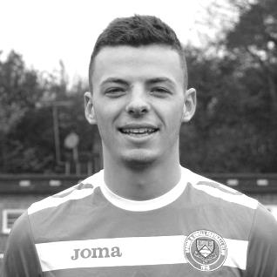
Our latest player profile is from one of our versatile defenders, James Taylor.

Age: 22

Position: Centre back

Club supported: Spurs

Favourite Food: Thai

Favourite Film: Taken

Messi or Ronaldo: Messi

Favourite Drink: Peroni

Favourite Ground played at: Kingfield, Woking F.C.

Best moment for Epsom: Scoring two goals in one game v Hanworth Villa (21/11/15)

Describe the Gaffa in three words: Angry - Red - Head

James’ Playing Stats: First Team Debut : 26/08/2013

Appearances: 76 - Sub: 11 - Total: 87 - Goals: 5

From behind the goal
Epsom & Ewell 2-1 Spelthorne Sports
Combined Counties League – Premier Division - Tuesday 1st March 2016

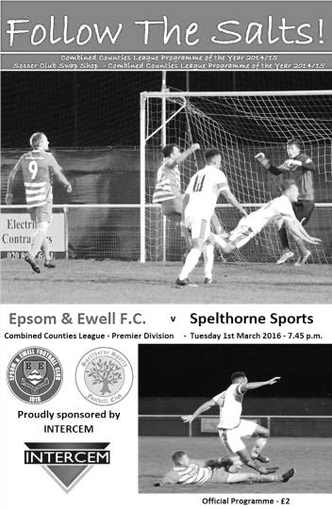
Epsom back on track thanks to Ferdinando stunner

A Matt Ferdinando free kick from twenty five yards at the commencement of the second half proved to be the difference between two evenly matched teams at High Road on Tuesday evening.

Epsom nearly took the lead in the 12th minute after Kyle Hough put Rob Hendry through but he lifted his shot just over the bar while Ferdinando tested Dane Buss with a free kick from distance but the danger was cleared. However, the visitors were competitive throughout and were unfortunate to go behind in the 40th minute when a deep ball in was only half cleared by the defender to Hendry who set Hough up for a smart low finish. There were shouts of offside against Hough when the ball originally came in, but the ball never reached him, so I can see why the play wasn't stopped.

Discussions about our goal were soon ended when Spelthorne equalised within ninety seconds; Simo Mbonkwi's excellent low drive from a narrow angle just beating Michael Eacott's outstretched hand. Fortunately for Epsom a free kick, awarded for a clumsy foul on Matt Farrell was clinically dispatched from 25 yards by Ferdinando in the 47th minute; his free kick glancing the keeper's right hand post as it flew in. Then just four minutes later Buss made an incredible stop from Matt Farrell just a couple of yards out after Craig Hastings had squared a deep cross to him. The visitors kept battling all the way and nearly equalised at the death with a far post header, although Eacott was well positioned to save.

It could be argued that Ferdinando's goal was deserving of winning any game and ultimately that's how it turned out. Although not the best game to watch with neither team able to retain possession for long, and the play becoming fragmented as a result, it was important to start picking up points again after two recent home defeats and we now visit Chertsey on Saturday in confident mood.

Team: Michael Eacott, Rhys North, Matt Tanton, Craig Hastings, Alex McKay, Bentley Graham, Reisse Griffin, Matt Farrell (c), Kyle Hough, Rob Hendry, Matt Ferdinando

Subs: Sam Currie for North (75), Elliott Thompson for Graham (81), Tom Neale for Hendry (85)

From behind the goal
Chertsey Town 3-5 Epsom & Ewell
Combined Counties League – Premier Division - Saturday 5th March 2016

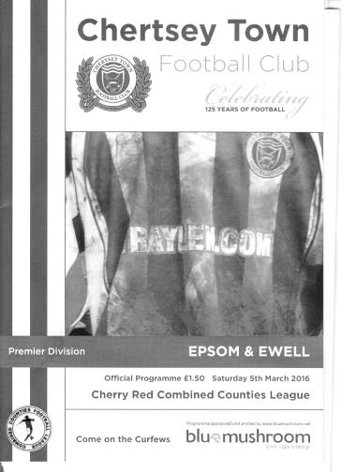
More away day joy for Salts

So far this season Epsom and Ewell have lost just one away league match and were never in doubt of losing this one, even if the ending of the match was not ideal.

We were in front inside two minutes. A Matt Ferdinando free kick was scuffed into the home wall but the ball rebounded to Bentley Graham who drilled a low shot into the corner from outside the penalty area. A good start became a great one when Graham found Rob Hendry whose low shot again gave the keeper no chance in the fifth minute.

The game became more even for a while but a fine pass from Reisse Griffin found Kyle Hough with just one man to beat and he skipped past him and buried his shot into the bottom corner after 29 minutes. A perfect first half was spoiled in injury time when a lack of communication between goalkeeper and defenders enabled the Chertsey striker to nip in between them and his lob over Michael Eacott was the final action of the opening period.

The second half started with a bit of home pressure but we weathered the storm and extended our lead in the 63rd minute when a great low cross from Ferdinando out on the right was forced on at the far post by Matt Farrell and four minutes later a Matt Tanton left wing cross found Ferdinando in acres of space and he drilled his shot beyond the keeper to become our fifth different scorer on the afternoon.

Despite pushing for a sixth goal we were caught out after Eacott flapped at a corner and the loose ball was nodded in to the empty net in the 88th minute and within a minute the home side forced home a third goal with a shot at the far post and our defence missing entirely. It was a disappointing way to end the match but we have now scored at least five on three occasions away from home this season and this 5-3 away win; our first I am informed, since November 2008 at Raynes Park Vale, enables us to keep pace with the leaders in the process.

Team: Michael Eacott, Rhys North, Matt Tanton, James Taylor, Craig Hastings, Bentley Graham, Reisse Griffin, Matt Farrell (c), Kyle Hough, Rob Hendry, Matt Ferdinando

Subs: Sam Currie for North (61), Elliott Thompson for Graham (68),
Tom Neale for Ferdinando (76)

Club Records - 12th March
Date | Day | Competition |  | Opponents |  | Scorers
12/03/27 | Sat | Surrey Senior League | H | Farnham United Breweries | 6-3 | R.Marlow (3), F.Behn (2), F.Watts
12/03/32 | Sat | London League | H | Grays Athletic | 3-1 | R.Marlow (2), B.Williams
12/03/38 | Sat | London League | A | P.O.Engineers | 1-2 | J.Jones
12/03/55 | Sat | Corinthian Memorial Shield 2 | A | Uxbridge | 1-5 | G.Hurst
12/03/60 | Sat | Corinthian League | H | Erith & Belvedere | 3-3 | S.Law (2), N.Dearlove
12/03/66 | Sat | Athenian League 2 | A | Lewes | 4-4 | P.Scott (2), D.Hollands, A.Cox
12/03/77 | Sat | Athenian League 1 | A | Letchworth Garden City | 1-3 | T.Tuite
12/03/83 | Sat | Isthmian League 1 | H | Wembley | 0-0
12/03/85 | Tue | Isthmian League  Premier Division | H | Leytonstone/Ilford | 0-0
12/03/88 | Sat | Isthmian League 2s | H | Eastbourne United | 0-1
12/03/94 | Sat | Isthmian League 3 | A | Flackwell Heath | 2-2 | N.Webb, A.Nimmo
12/03/02 | Tue | Surrey Senior Cup QF | H | Crystal Palace | 1-3 | G.Morris (pen)
12/03/05 | Sat | Isthmian League 2 | H | Witham Town | 0-5
12/03/11 | Sat | Combined Counties  Premier Division | A | Guildford City | 1-3 | A.Panayi
Historical Decades
Date | Day | Competition |  | Opponents |  | Scorers
90 years ago – Epsom Town F.C.
13/03/26 | Sat | Surrey Senior League | A | Guildford | 1-1 | R.Marlow
80 years ago – Epsom F.C.
14/03/36 | Sat | Surrey Charity Shield SF | H | Redhill | 0-2
70 years ago – Epsom F.C.
09/03/46 | Sat | Friendly | H | West Ham 'A' | 4-3 | K.Minter, F.Chitty, G.Brogdale, K.Holliday
60 years ago – Epsom F.C.
10/03/56 | Sat | Corinthian League | H | Uxbridge | 1-0 | B.Jenkins
50 years ago – Epsom & Ewell F.C.
12/03/66 | Sat | Athenian League 2 | A | Lewes | 4-4 | P.Scott (2), D.Hollands, A.Cox
40 years ago – Epsom & Ewell F.C.
13/03/76 | Sat | Athenian League 2 | H | Edgware | 2-2 | K.Eshelby, T.Tuite
30 years ago – Epsom & Ewell F.C.
11/03/86 | Tue | Isthmian League  Premier Division | A | Wokingham Town | 1-3 | R.Lewis
20 years ago – Epsom & Ewell F.C.
14/03/96 | Thu | Isthmian League 3 | H | Lewes | 0-0
10 years ago – Epsom & Ewell F.C.
11/03/06 | Sat | Isthmian League 2 | A | Flackwell Heath | 0-2

History Corner - 12th March
89 years ago today we had the final instalment of our rivalry with Farnham United Breweries. When we joined the Surrey Senior League in 1924 they were top dogs; League and Cup Champions and would go on to retain both in 1924/25. In 1925/26 we won the League while they retained the Cup but in 1926/27 it would be our turn for a double as two weeks previously we had defeated them in the Charity Cup 5-2 at West Street and this day we would prove it was no fluke with a 6-3 home win in the League. Reg Marlow was on target with his eleventh hat trick of the season, while the two Freds, Behn and Watts, scored the others. Despite the size of the win, the Epsom papers advised that “Epsom were well below their usual form”! Based on this win, our club called a Special General Meeting where it would be decided whether they should make the step up to a higher level of play. We applied for the London League that month and the two clubs would never meet again. In fact the Brewery side never even started the following season after a buy out of the Brewery by Courage.

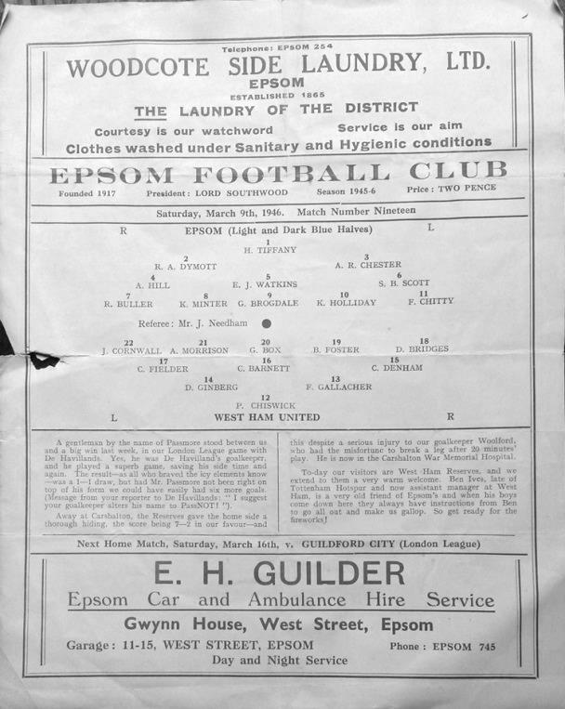
70 years ago this week we hosted a West Ham reserve side in a friendly, winning 4-3. We were not that good during the first post-war season, so the standard of the East London professional eleven was probably not that great either, although it did contain two time F.A. Cup winner Jim Barrett Senior according to the papers. This was a bit of an exaggeration as West Ham didn’t win the F.A. Cup before 1964, but he was a long serving player with over 400 first team appearances and the shortest ever English International career, playing once against Northern Ireland but lasting only four minutes before succumbing to injury! His son, another West Ham professional by the same name played alongside him in the ‘A’ team in 1945/46 but not in this match it appears from the advertised programme line up. (see right)

50 years ago today there was a wild match at the Dripping Pan which ended with eight goals shared. It was 3-3 at half time and Peter Scott scored his second goal in the later period but did not recall it afterwards having received a blow on the head. The paper read that Scott "picked up the ball near the end of the game, and sped goalwards, still clutching his bottle of smelling salts"!

30 years ago this week we visited Wokingham Town’s much missed Finchampstead Road ground for an Isthmian League Premier Division match more in hope than expectation. We were battling relegation and had not won an away league match all season but were level at half time before falling away to trail 3-0. A great lob from Robin Lewis reduced the deficit but despite finally recording an away win at Worthing the next week, the damage had been done and by the end of the season we had gone down. Lewis had departed for better things, not least in scoring a winner for Enfield to knock Leyton Orient out of the F.A. Cup in November 1988!

First Eleven Appearances - (max 35 – including Chertsey Town – 05/03/16)
Name | Debut | 2015/16 |  |  |  | Career Totals
Name | Debut | App | Sub | Total | Goals | App | Sub | Total | Goals
AJAYI Tayo* | 22/08/2015 | 0 | 2 | 2 | 0 | 0 | 2 | 2 | 0
COOPER-SMITH Daryl | 03/01/2015 | 15 | 4 | 19 | 8 | 24 | 7 | 31 | 14
CURRIE Sam | 04/08/2012 | 16 | 4 | 20 | 1 | 124 | 13 | 137 | 3
DAVISON Conor* | 22/08/2015 | 1 | 2 | 3 | 0 | 1 | 2 | 3 | 0
DEAN Dan | 02/08/2014 | 22 | 2 | 24 | 0 | 58 | 3 | 61 | 0
DOWNS Carl | 17/09/2011 | 5 | 1 | 6 | 0 | 99 | 14 | 113 | 2
EACOTT Michael | 02/08/2014 | 31 | 0 | 31 | 0 | 77 | 0 | 77 | 0
FARRELL Matt | 02/08/2014 | 34 | 0 | 34 | 6 | 75 | 3 | 78 | 13
FERDINANDO Matt | 20/09/2014 | 24 | 1 | 25 | 8 | 51 | 5 | 56 | 14
GRAHAM Bentley | 09/02/2016 | 6 | 0 | 6 | 1 | 6 | 0 | 6 | 1
GRIFFIN Reisse | 08/08/2015 | 16 | 6 | 22 | 1 | 16 | 6 | 22 | 1
HASTINGS Craig | 08/08/2015 | 28 | 3 | 31 | 0 | 28 | 3 | 31 | 0
HATFIELD Jamie | 11/11/2006 | 1 | 0 | 1 | 0 | 249 | 13 | 262 | 6
HENDRY Rob | 08/08/2015 | 27 | 6 | 33 | 12 | 27 | 6 | 33 | 12
HOUGH Kyle | 14/08/2007 | 25 | 4 | 29 | 21 | 321 | 19 | 340 | 192
JONES Adrian | 06/08/2011 | 3 | 1 | 4 | 0 | 23 | 1 | 24 | 0
KURDZIEL Jakub* | 29/08/2015 | 1 | 0 | 1 | 0 | 1 | 0 | 1 | 0
MARVELL Dale* | 15/01/2000 | 8 | 4 | 12 | 1 | 269 | 49 | 318 | 86
McGREGOR Alex* | 08/08/2009 | 7 | 3 | 10 | 2 | 179 | 59 | 238 | 29
MCKAY Alex | 20/12/2008 | 23 | 1 | 24 | 0 | 108 | 27 | 135 | 8
NEALE Thomas | 13/10/2015 | 12 | 11 | 23 | 6 | 12 | 11 | 23 | 6
NEILL David* | 03/10/2015 | 1 | 1 | 2 | 0 | 1 | 1 | 2 | 0
NORTH Rhys | 16/08/2015 | 16 | 7 | 23 | 1 | 16 | 7 | 23 | 1
OLIVER Beckett | 29/08/2015 | 5 | 11 | 16 | 0 | 5 | 11 | 16 | 0
PANAYIOTOU Savvas | 03/01/2015 | 7 | 3 | 10 | 1 | 23 | 6 | 29 | 4
ROBINSON Sam* | 22/10/2011 | 0 | 1 | 1 | 0 | 54 | 5 | 59 | 13
ROWE Steve | 27/08/2011 | 0 | 1 | 1 | 0 | 24 | 3 | 27 | 0
SMITH Matt | 08/08/2009 | 0 | 0 | 0 | 0 | 91 | 43 | 134 | 10
TANTON Matt | 02/08/2014 | 29 | 0 | 29 | 0 | 47 | 4 | 51 | 1
TAYLOR James | 26/08/2013 | 20 | 3 | 23 | 2 | 76 | 11 | 87 | 5
THOMPSON Elliott | 09/02/2016 | 2 | 4 | 6 | 0 | 2 | 4 | 6 | 0
Own Goal |  |  |  |  |  |  |  |  | 1
* Player has left the club

Combined Counties League Premier Division Opponents
All-time Records
inc Saturday 5th March | P | W | D | L | F | A | PPG | GD | Best  Win | Worst  Loss
Spelthorne Sports* | 5 | 4 | 1 | 0 | 15 | 6 | 2.60 | +9 | 6-2 | -
Sutton Common Rovers | 10 | 8 | 1 | 1 | 27 | 12 | 2.50 | +15 | 4-0 | 1-4
Horley Town | 28 | 19 | 5 | 4 | 62 | 30 | 2.21 | +32 | 6-0 | 1-3
Westfield | 17 | 11 | 3 | 3 | 39 | 27 | 2.12 | +12 | 6-1 | 0-4
Colliers Wood United | 21 | 14 | 2 | 5 | 45 | 28 | 2.10 | +14 | 4-0 | 0-3
Knaphill | 5 | 3 | 1 | 1 | 10 | 6 | 2.00 | +4 | 4-1 | 1-2
Bedfont Sports | 9 | 5 | 2 | 2 | 13 | 10 | 1.89 | +3 | 3-0 | 0-4
Guildford City | 15 | 8 | 1 | 6 | 27 | 21 | 1.67 | +6 | 4-0 | 1-5
Farnham Town | 12 | 6 | 2 | 4 | 21 | 21 | 1.67 | 0 | 3-1 | 1-4
Raynes Park Vale | 25 | 12 | 5 | 8 | 54 | 36 | 1.64 | +18 | 6-1 | 0-2
Hanworth Villa | 13 | 6 | 3 | 4 | 31 | 22 | 1.62 | +9 | 5-0 | 1-4
Camberley Town* | 87 | 38 | 21 | 27 | 156 | 120 | 1.57 | +36 | 9-1 | 0-4
Chessington & Hook | 27 | 11 | 9 | 7 | 52 | 41 | 1.56 | +11 | 6-0 | 1-3
Cove | 33 | 14 | 9 | 10 | 74 | 55 | 1.55 | +19 | 7-0 | 1-6
Hartley Wintney | 10 | 4 | 3 | 3 | 25 | 17 | 1.50 | +8 | 5-0 | 2-4
Windsor | 47 | 18 | 12 | 17 | 87 | 88 | 1.40 | -1 | 4-0 | 0-6
Redhill | 33 | 14 | 2 | 17 | 63 | 69 | 1.33 | -6 | 7-2 | 2-8
Badshot Lea | 16 | 6 | 3 | 7 | 27 | 32 | 1.31 | -5 | 3-0 | 0-4
Chertsey Town | 47 | 17 | 5 | 25 | 70 | 86 | 1.19 | -16 | 3-0 | 0-7
Ashford Town (Mx) | 17 | 4 | 2 | 11 | 22 | 44 | 0.82 | -22 | 3-0 | 0-5
AFC Hayes | 7 | 1 | 2 | 4 | 9 | 15 | 0.71 | -6 | 3-1 | 0-3
Total* | 484 | 223 | 94 | 166 | 929 | 786 | 1.58 | 143 | - | -
* includes one abandoned match v Camberley and one loss on penalties v Spelthorne

CCL Premier Division Club Directory
A.F.C. HAYES Telephone: 0208-845-0110 - Ground: Farm Park, Kingshill Avenue, Hayes, Middx. UB4 8DD - Colours: Blue and White Stripes/Blue/Blue

ASHFORD TOWN (Mx) Telephone: 01784-245908 - Ground: The Robert Parker Stadium, Short Lane, Stanwell, Middx. TW19 7BH - Colours: Tangerine & White Stripes/Black/Tangerine

BADSHOT LEA Telephone: 01252-320385 - Ground: Ash United FC, Shawfield Stadium, Youngs Drive, Shawfields Road, Ash, Hampshire. GU12 6RE - Colours: Claret/White/Claret

BEDFONT SPORTS Telephone: 0208-831-9067 - Ground: Bedfont Sports Club, Hatton Road, Bedfont, Middx TW14 8JA - Colours: Red & Black Hoops/Black/Red & Black Hoops

CAMBERLEY TOWN Telephone: 01276-65392 - Ground: Krooner Park, Wilton Road, Camberley, Surrey. GU15 2QW - Colours: Red & White Stripes/Blue/Red

CHERTSEY TOWN Telephone: 01932-561774 - Ground: Alwyns Lane, Chertsey, Surrey. KT16 9DW - Colours: Royal Blue & White Stripes/Royal Blue/Royal Blue

CHESSINGTON & HOOK UNITED Telephone: 01372-602263 - Ground: Chalky Lane, Chessington, Surrey. KT9 2NF - Colours: Blue/Blue/Blue

COLLIERS WOOD UNITED Telephone: 0208-942 8062 - Ground: Wibbandune Sports Ground, Robin Hood Way, Wimbledon. SW20 0AA - Colours: Blue & Black Stripes/Black/Black

COVE Telephone: 01252-543615 - Ground: Oak Farm Fields, 7 Squirrel Lane, Cove, Farnborough, Hampshire. GU14 8PB - Colours: Yellow/Black/Yellow

EPSOM & EWELL Telephone: 01737-553250 - Ground: Chipstead FC, High Road, Chipstead, Surrey. CR5 3SF - Colours: Royal Blue & White Hoops/Royal Blue/Royal Blue

FARNHAM TOWN Telephone: 01252-715305 Ground: Memorial Ground, Babbs Mead, West Street, Farnham, Surrey. GU9 7DY Colours: - Claret & Sky Blue /White/ Claret & Sky Blue

GUILDFORD CITY Telephone: 01483-443322 - Ground: The Spectrum, Parkway, Guildford, Surrey. GU1 1UP - Colours: Red & White Stripes/Black/Black

HANWORTH VILLA Telephone: 0208-831-9391 - Ground: Rectory Meadows, Park Road, off Hounslow Road, Hanworth, Middlesex. TW13 6PN - Colours: Red & White Stripes/Black/Black

HARTLEY WINTNEY Telephone: 01252-843586 - Ground: Memorial Playing Fields, Green Lane, Hartley Wintney, Hants RG27 8DL - Colours: Orange & Black/ Orange /Orange

HORLEY TOWN Telephone: 01293-822000 - Ground: The New Defence, Anderson Way, Court Lodge Road, Horley, Surrey. RH6 8SP - Colours: Claret & Sky Blue/Claret/Claret

KNAPHILL Telephone: 01483-475150 - Ground: Brookwood Country Park, Redding Way, Lower Guildford Road, Knaphill, Surrey. GU21 2AY - Colours: Red/Black/Red

SUTTON COMMON ROVERS Telephone: 01932-866386 - Ground: Sutton United FC, Gander Green Lane, Sutton, Surrey SM1 2EY - Colours: Yellow/Black/Black

RAYNES PARK VALE Telephone: 020-8540-8843 - Ground: Prince Georges Playing Field, Grand Drive, Raynes Park, London. SW20 9NB - Colours: Blue/Blue/Red

REDHILL Telephone: 01737-762129 - Ground: Kiln Brow, Three Arch Road, Redhill, Surrey RH1 5AG - Colours: Red and White Stripes/Black/Red

SPELTHORNE SPORTS Telephone: 01932-961055 - Ground: Spelthorne Sports Club, 296 Staines Road, Ashford Common, Ashford, Middx. TW15 1RY - Colours: Light & Dark Blue/Dark Blue/Light Blue

WESTFIELD Telephone: 01483-771106 - Ground: Woking Park, Kingfield Road, Woking, Surrey. GU22 9BA - Colours: Yellow/Black/Black

WINDSOR Telephone: 01753-860656 - Ground: Stag Meadow, St Leonards Road, Windsor, Berks SL4 3DR - Colours: Red/Red/Red

EL Records Premier Challenge Cup
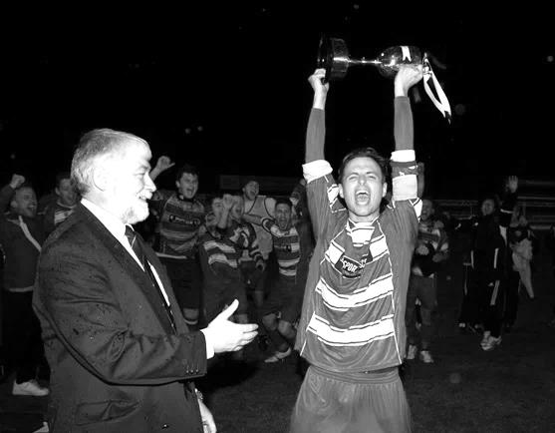
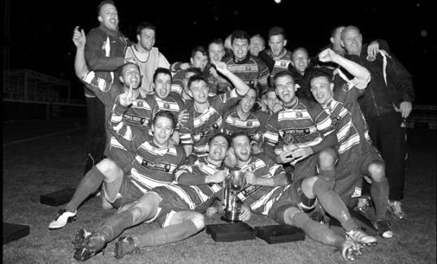
Second Round
Dorking Wanderers | 2-1 | South Park Reserves
Westfield | 1-0 | CB Hounslow United
Bedfont & Feltham | 1-5 | Colliers Wood United
Dorking | 0-3 | Knaphill
Badshot Lea | 2-4 | Spelthorne Sports
Hanworth Villa | 1-2+ | Chertsey Town
Ashford Town (Mx) | 2-1 | Epsom Athletic
Hartley Wintney | 4-2 | Horley Town
Banstead Athletic | 1-1+ | Epsom & Ewell
Epsom & Ewell won 7-6 on penalties
Sheerwater | 3-3+ | Frimley Green
Frimley Green won 8-7 on penalties
Farnham Town | 3-2 | Abbey Rangers
Camberley Town | 4-2 | Eversley & California
AFC Hayes | 0-1 | Banstead Athletic
Redhill | 3-0 | Sutton Common Rovers
Worcester Park | 1-5 | Chessington & Hook United
Cove | 1-6 | Cobham
Third Round
Camberley Town | 5-1 | Spelthorne Sports
Cobham | 3-0 | Frimley Green
Redhill | 0-2 | Farnham Town
Raynes Park Vale | 0-2 | Westfield
Epsom & Ewell | 0-3 | Ashford Town (Mx)
Colliers Wood United | 6-0 | Dorking Wanderers Reserves
Knaphill | 2-1 | Chertsey Town
Hartley Wintney | 0-1 | Chessington & Hook United
Quarter Finals
Camberley Town | 2-1+ | Colliers Wood United
Chessington & Hook United | 0-3 | Ashford Town (Mx)
Match played at Ashford Town (Mx) FC
Cobham | 2-0 | Westfield
Knaphill | 1-3 | Farnham Town

Centre page for results

Centre page for results



Knaphill – History
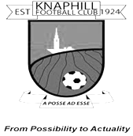
Knaphill Football Club began its life in 1924 at Waterer's Park, which was left to Woking Urban District Council in 1924 by Mr Anthony Waterer of Knaphill Nursery. The Recreation Ground was originally part of the nursery called "Blue Gates Field" and the park was laid out by Woking Council between 1924 and 1928.

Very little history is known or available about the Club between 1924 and 1980. In 1980, Knaphill were represented in the Old Woking and District League (now Guildford and Woking Alliance League) in Division 3 under Manager Dave Holloway. Dave took them from Division 3 through promotion to the Surrey Intermediate League.

Mick Garbutt became the Manager of Knaphill in 1990, but in 1994 departed to join up with Colin Lippiatt and Geoff Chapple at Woking. In 1996 David Freeman took over from First Team Manager Greg Anderson, who was in charge for just one season 1995/96. Sean Carrigy was Reserve Team Manager. Season 2002/03 saw 2 new men at the helm with Mick Garbutt in charge of the 1st Team and Frank Walters the Reserves.

Season 2005/2006 was destined to be a big season for the club with the club established at new ground at Redding Way and the’ A’ team reverting back to Waterers Park having had the facilities rebuilt. 1st Team Manager David Freeman continued in charge for the 2005/2006 campaign and appointed former professional with Bristol City, Bob Pritchard, who had also managed at senior level with Chertsey Town. The 2005/2006 season did prove successful as we won the Division One title on the last day of the season against nearest rivals Virginia Water and gained promotion to the Premier Division.

2006/2007 continued with David Freeman in charge of the 1st Team who claimed back to back titles by winning the Premier Division Championship which resulted in us achieving promotion to the Combined Counties Football League, the most successful period in the clubs history up to then. Bob Pritchard took over from David Freeman as Manager who then became Bob’s assistant during September 2007. They took the team to a very commendable 7th place in the CCL, our first in senior football. Steve Hutton led the Reserves campaign, with a massive 40 games in the season.

The 2008/09 season started with former Bisley and Farnborough Assistant Manager, Ian Savage joining the Club as player/coach. The team kept a high profile in the League staying in the top half of the table all season, eventually finishing in fifth place. They could have become champions had they won their last game of the season when, in a tightly bunched set of teams in the top six. Knaphill on 69 points needed to win at Farleigh to pip Staines Lammas to the title. Disappointingly they lost 3-2, so near yet so far!

The Reserves finished ninth in their Division with the second half of the season providing

a 17 match sequence losing just two games. The 2009/10 season saw the team finish third in Division One, their best placing in the three seasons in the Combined Counties League. Third would normally have gained the Club promotion, but due to the proposed floodlights installation being delayed, Knaphill had to make another challenge for promotion in 2010/11. The team won 26 out of their 40 league games, losing 10 with 4 drawn, scoring 98 goals and finished with 82 points.

Season 2010/11 was one of two halves for the first team, having suffered a poor string of results in the first four months of the season, the turn of the year went onto see an unbeaten run of 12 matches. But the run was not enough to see us get close enough to a promotion place, and after reaching fifth in the table in the final run in.

The newly formed Knaphill Youth U18s, played their first season in the Allied Counties League, and reached the final of the Grant McLellan Youth Cup, but lost 2-0 to Bedfont Sports. The 2011/12 season saw Knaphill entering the FA Vase for the first time, and the team finished 12th in Division One. Our Youth team reached the Grant McLellan Cup final for the second year running, but were beaten finalists. Chairman Terry Chapman stood down as Chairman, and David Freeman, 16 years at Knaphill, took over the role in the first half of the season. Season 2012/13, the 1st team finished 12th in Division One.

So season 2013/14 emerged with Phil Ruggles as 1st team Manager, and Steve Pearman as his Assistant, and players wise, many new faces in the squad. It was Knaphill;s seventh season in the Combined Counties League, and it proved to be a season that showed more progression for the Club. There was also a nice ‘mini run’ in the F.A. Vase with wins over Badshot Lea, Tadley Calleva and Dorking, before going out of the competition at home to East Preston. League success saw Knaphill gain promotion to the Premier Division.

More progress came in the Club’s 90th year when the 2014/15 season saw Knaphill make their debut in the Premier Division, and entry into the FA Cup for the first time.

It was a tough first season in the Premier, but they stabilised their position and April was their best month of the League season with an unbeaten sequence with four wins and a draw, accumulating 13 points out of a possible fifteen, to push the team up to a healthier finish in the League, just a couple of points under the halfway placings in the table.

In the F.A. Cup and F.A. Vase the team played three rounds in both Competitions. Wins against Fairford Town and Badshot Lea before losing to Fleet Town in the Cup, whilst in the Vase there were wins at Woodley Town and Lordswood, but like the F.A. Cup, lost in their third match of the Vase away to Hanworth Villa. The Club were in the Surrey Senior Cup for the first time during last season, but were knocked out of the competition by Colliers Wood.

Manager Phil Ruggles left the Club in January with Keith Hills taking over as caretaker Manager for the remainder of the season. Keith and everyone at Knaphill will be looking for further progress with League, FA Cup, FA Vase, and other Cup competitions on their agenda for the 2015/16 season.

Every Opponent A-Z
Over the years we have played many, many different opponents. Exactly how many is a difficult question, as it all depends on your definition. Are Camberley & Yorktown different to Camberley Town, or are Epsom Town different to Epsom F.C. or Epsom & Ewell F.C.?

In my analysis I have classed them as the same team, and will work through them all from A to Z. Some we have played many times, whilst others we have met just once or twice. Enjoy!


Royston Town: Played 7 - W3 D2 L2 - F10 A6 - PPG - 1.57 - Above Average

Matches with Royston occurred over the period 1991-94, comprising just six League matches and an Associate Members Trophy tie in total. There is very little to report on them in all honesty!

Certainly the first meeting on the opening day of the 1991/92 season was the most notable and even that had nothing to do with the match. This was our first match in the newly constituted Isthmian League Division Three and as if to underline that our journey time would increase, we faced our longest journey of the season straight off. However, the view that greeted supporters was unusual as this day we saw the new style kit for the first time, as our boys modelled the blue and white hoops that have now been in existence for twenty five years.

Of course nowadays we don’t think of our team wearing anything else but the all blue shirts were consigned to history on a theory that Manager Adrian Hill had, that it would make our young team look larger! We lost 2-1 that day, although in January of 1992 they had to make the reverse journey in midweek for an Associate Members Trophy match. They arrived late as we defeated them 4-1 thanks mainly to a hat trick from Andy Webster and in the return League match, again on a Tuesday in March, we won again 1-0.

The following season, our last at West Street resulted in a repeat 2-1 defeat at Garden Walk, but only a 1-1 home draw in March of 1993. However, in 1993/94 we secured a goalless draw there and won 2-0 at home, meaning that neither team won an away match in the entire sequence.

Despite finishing eighth that season, Royston resigned from the Isthmian League after being told that they had to build a new stand at a cost of some £20,000 if they were to remain in the League. The resignation did them no harm and nowadays they are members of the Southern League Central Division at Step Four. I do not know whether the new stand was ever built!

Ruislip Manor: Held over to next issue

Saltdean United: Played 1 - W1 D0 L0 - F1 A0 - PPG - 3.00 - Perfect

Saltdean play at the very picturesque Hill Park and had been as high as the first division of the Sussex League in previous years. However, by the time we met in the F.A. Vase in September 2008, they were a Step Seven team playing in Sussex Division Three, representing a huge banana skin for us. Luckily a Gary McLaughlin close range goal was enough to see us through that day.

They currently play in the Sussex League Division Two but are rock bottom and appear headed for a return to Intermediate football.

Sandhurst Town: Played 14 - W5 D0 L9 - F25 A28 - PPG - 1.07 - Poor

Looking back at this I am surprised that we have such a poor record against the team from Bottom Meadow. We met for seven straight seasons until their relegation in 2013 and games were always competitive but five defeats in seven matches there, all of which were close affairs, do not help our record against the Fizzers.

We first met in January 2007 and although we equalised an early goal with a great Dale Marvell strike from forty yards, we conceded a second half winner. In the return we trailed again and then equalised with a similarly long shot from distance, this time from Phil N’gbale, but this time Scott Murphy side-footed the winner from close range to reverse the scoreline.

The following season we lost 2-0 on a very cold day at Merland Rise before fighting back from a two goal deficit at the Meadow, only to then concede a third goal after doing the hard work!

In 2008/09 we were destined for a fourth place finish and recorded a double over Sandhurst. Our 4-2 win there was notable for an equalising strike of high quality from Charlie West, followed by the perfect hat trick from Kyle Hough; one each with either foot and a header! At home we trailed again but second half goals from Robbie Burns and Dale Marvell enabled us to turn it around again for a 2-1 win.

In 2009/10 we were again behind by two goals but won 3-2 in the end. However, five straight defeats would follow. That sequence was finally broken in what would prove to be Sandhurst’s relegation season as we beat them by four clear goals at home. Even then, our own inconsistencies were shown up in April 2013 when we visited the bottom side, operating an unusual experiment of playing centre half Anthony Panayi up front and we paid the price with a 2-1 defeat. They jumped over Dorking as a result and finished second from bottom but only Ash United, one place above them were reprieved and Sandhurst went down. They remain at Step Six currently.

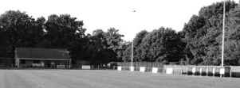
Two views of Bottom Meadow. Above: Club house, dug outs and main standing area. Below: Their stand, added in around 2008.

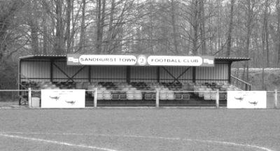

Surrey Senior Cup
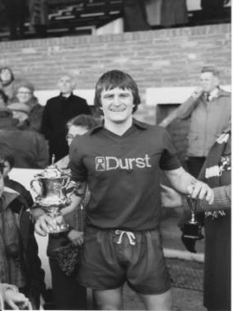
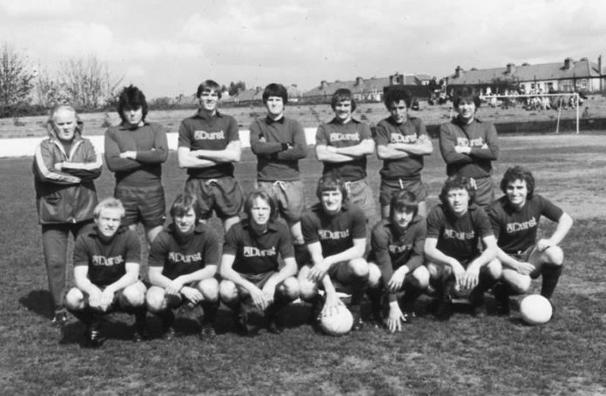
Second Round
Knaphill | 4-3 | Ashford Town (Mx)
Chipstead | 4-1 | Chessington & Hook United
Colliers Wood United | 1-3 | Whyteleafe
Corinthian Casuals | 1-1 CC 4-2p | Egham Town
Croydon | 3-3 F 3-2p | Farnham Town
Godalming Town | 1-0 | Guildford City
Horley Town | 2-2 BL 4-3p | Badshot Lea
Leatherhead | 3-0 | Carshalton Athletic
Merstham | 3-0 | South Park
Met Police | 3-2 | Dorking Wanderers
Molesey | 2-1 | Raynes Park Vale
Redhill | 0-3 | Tooting & Mitcham United
Sutton United | 3-0 | Walton & Hersham
Walton Casuals | 1-1 K 9-8p | Kingstonian
Westfield | 2-0 | Chertsey Town
Woking | 10-0 | Sutton Common Rovers
Third Round
Godalming Town | 1-2 | Tooting & Mitcham United
Godalming Town reinstated as Tooting & Mitcham United played an ineligible player
Whyteleafe | 6-0 | Farnham Town
Kingstonian | 0-1 @ LFC | Leatherhead
Badshot Lea | 1-5 | Merstham
Westfield | 1-4 @ Woking | Woking
Met Police | 0-1 | Molesey
Knaphill | 3-0 | Chipstead
Corinthian Casuals | 1-3 | Sutton United
Quarter Finals
Molesey | 1-3 | Woking
Knaphill | 0-1 @ Sutton | Sutton United
Whyteleafe | 0-3 | Godalming Town
Leatherhead | 0-4 | Merstham
Semi Finals
Sutton United | 15/3 | Godalming Town
Woking | 15/3 | Merstham

F.A. Vase
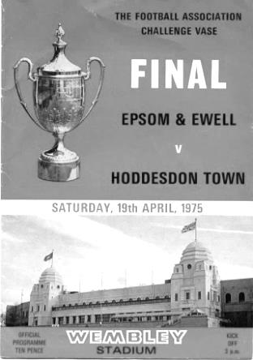
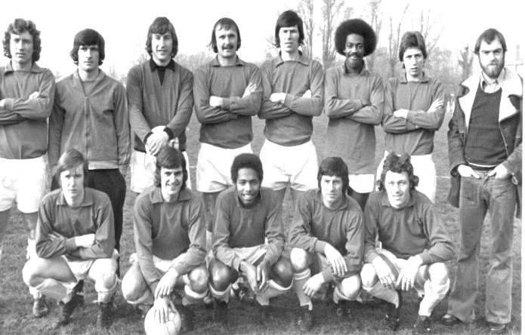
Fourth Round
Cleethorpes Town | 2-1 | Alvechurch
Hereford | 6-0 | Leicester Nirvana
Morpeth Town | 2-0 | North Shields
Coleshill Town | 1-3+ | Dunston UTS
AFC Wulfrunians | 2-3 | Nuneaton Griff
Sunderland RCA | 3-2 | Sleaford Town
Newton Aycliffe | 2-0 | Marske United
Bowers & Pitsea | 3-0 | Sutton Common Rovers
Kidlington | 3-2 | Knaphill
Newport IOW | 1-2+ | Ashford United
Moneyfields | 0-2 | Bristol Manor Farm
FC Romania | 1-2 | Camberley Town
AFC Dunstable | 0-3 | Salisbury
Berkhamsted | 4-2 | Hullbridge Sports
Hartley Wintney | 3-1 | Bradford Town
Bodmin Town | 1-3 | Ipswich Wanderers
Fifth Round
Ipswich Wanderers | 1-1+r1-2 | Bowers & Pitsea
Sunderland RCA | 2-3 | Bristol Manor Farm
Camberley Town | 5-0 | Newton Aycliffe
Berkhamsted | 1-2 | Morpeth Town
Cleethorpes Town | 1-2 | Kidlington
Nuneaton Griff | 0-3 | Salisbury
Ashford United | 1-1+r3-2 | Dunston UTS
Hartley Wintney | 1-4 | Hereford
Quarter Final
Hereford | 3-2+ | Camberley Town
Salisbury | 3-0 | Ashford United
Morpeth Town | 2-0 | Bristol Manor Farm
Bowers & Pitsea | 3-3+4-0 | Kidlington
Semi Final (two legs) 12-03-16 and 19-03-16
Hereford | V | Salisbury
Morpeth Town | V | Bowers & Pitsea

Player Sponsorship
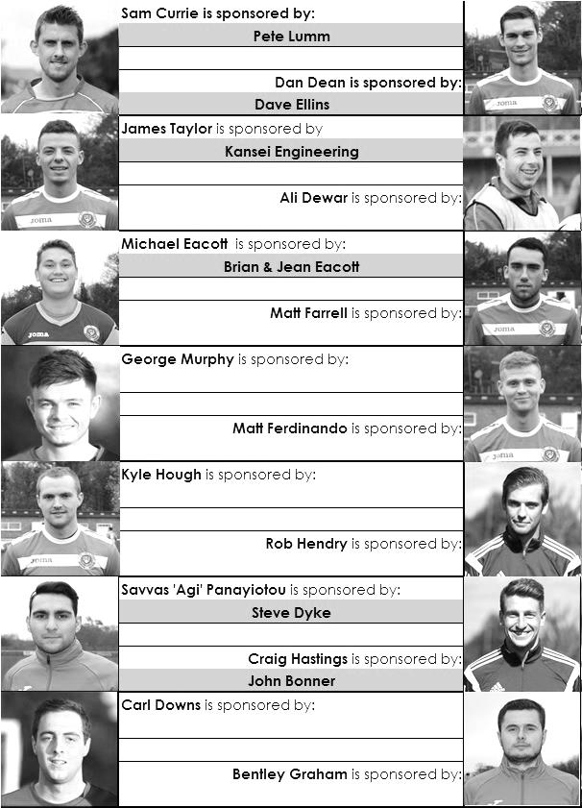

Here is the current list for the 2015/16 season showing all of our players and Management that are currently available for sponsorship this season.

Sponsorship costs just £40 and it is easy to do. Just select a player who has not been previously sponsored and let a Committee Member know that you would like to sponsor them. Beware though. Until we have received the money it is possible for someone to jump in front of you, so don’t delay, sponsor today!
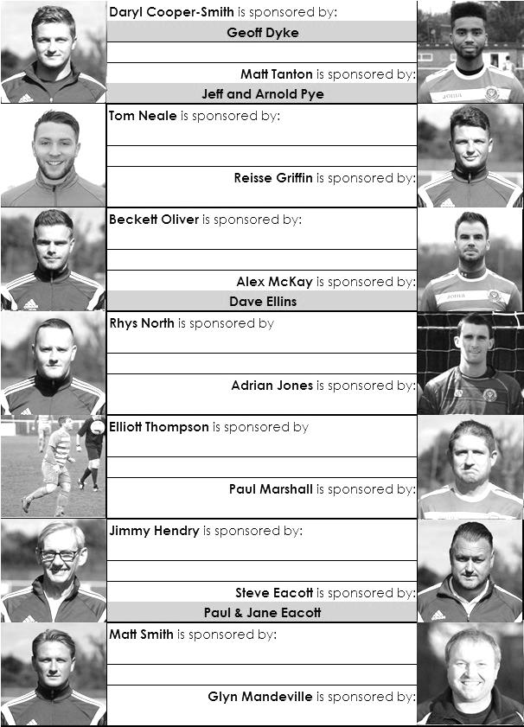

Match and Ball Sponsorships – 2015/16
Opponent | Date | Match Sponsor | Match Ball Sponsor
Hoddesdon Town | 18/07/15 | Geoff Dyke
Windsor | 08/08/15 | Club President - Stella Lamont
Erith & Belvedere (FAC) | 16/08/15 | Committee Member - Mike Lovett
Raynes Park Vale | 31/08/15 | EEFC Management Committee
Colliers Wood United | 08/09/15 | Bookham Building Shop – www.buildingshop.co.uk
AFC Hayes | 19/09/15 | John Bonner
Farnham Town | 26/09/15 | Ezara and Inaya Beddoe – our youngest supporters!
Chertsey Town | 17/10/15 | Club Media Officer – Richard Lambert
Dorking Wanderers (SSC) | 20/10/15 | Tony Ferdinando
Chessington & Hook United | 07/11/15 | Paul Merritt
Hanworth Villa | 21/11/15 | Maggie Beddoe
Guildford City | 05/12/15 | Pete Lumm
Sutton Common Rovers | 19/12/15 | Marvin Hough
Ashford Town (Mx) (LC) | 12/01/16 | Pete Beddoe & Steve Dyke
Redhill | 02/02/16 | David Lawton
Bedfont Sports | 13/02/16 | Bookham Building Shop – www.buildingshop.co.uk
Hartley Wintney | 23/02/16 | EEFC Management Committee
Horley Town | 27/02/16 | Jeff and Arnold Pye
Spelthorne Sports | 01/03/16 | In memory of Chris Henry
Knaphill | 12/03/16 | Marvin Hough
Cove | 15/03/16
Westfield | 26/03/16 | Nathan Lambert
Badshot Lea | 09/04/16 | Tony Coome
Camberley Town | 16/04/16
Ashford Town (Mx) | 30/04/16 | Club President - Stella Lamont
Ashford Town (Mx) | 30/04/16 | Brian Eacott | Steve Dyke
For League, League Cup and Surrey Senior Cup Matches:
Match sponsorship - £40.00 Match ball sponsorship - £25.00. Combined £55.00.
For F.A. Cup and F.A. Vase matches:
Match sponsorship - £50.00 Match ball sponsorship - £30.00. Combined £65.00.

Sponsorship includes: ( x2 for match, x3 for match and ball )

Admission, programmes, hospitality, advertising and mascot for the day (if required ).
If you are interested, just speak to a Committee Member, or drop me an email at: richard.c.lambert@gmail.com


We also thank our Kit Sponsors INTERCEM

Salts Super Six Predictor
The Salts Super Six Predictor Competition is live again and the tickets are on sale at today’s game to the left of the gate. We recently had our third Super Six win when three different participants all won a share. Jim Dean, father of Dan is on the cover receiving his cheque from Steve Dyke our Treasurer.

The competition is easy to play! To win, you simply need to predict the results of the six matches correctly from the three options, fill in the form and make sure it is back with our sellers before the deadline on the ticket.

If you are a club regular, you just need to place your name on the sheet, although if you aren’t, then we’ll need a contact number from you too. We will announce any winners on the website very quickly, so don’t worry we won’t miss you!
The jackpot is now at £62 and who knows how high it could go this time!

Please note that if there is more than one winner, the prize pot would be shared between the winners. All you need to do now is have a go, as many times as you like!

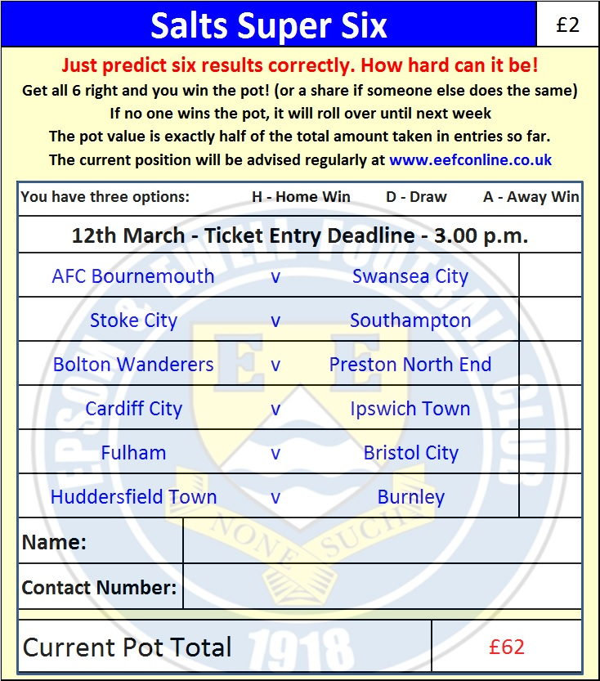

Good luck!

Combined Counties League – Premier Division
Saturday, 12th March 2016 - Kick-off 3.00 p.m.
Epsom and Ewell  (Royal Blue & White hoops) | V |  | Knaphill  (All Red)
Squad | NUMBERS
Michael Eacott |  |  | Richard Shelley
© Sam Currie |  |  | Steve Brown
Matt Tanton |  |  | Timmy Taylor
Craig Hastings |  |  | Matt Morris
James Taylor |  |  | Jamie Doble
Dan Dean |  |  | Connor Close
Alex McKay |  |  | George Frith
Matt Farrell |  |  | Rob Kersley
Kyle Hough |  |  | Charlie Postance
Rob Hendry |  |  | Jack Mazzone
Matt Ferdinando |  |  | Josh Coke
Daryl Cooper-Smith |  |  | Danny Taylor
Beckett Oliver |  |  | Arafat Kabuye
Tom Neale |  |  | Alex Lumley
Carl Downs |  |  | Josh Watkins
Alex McGregor |  |  | Jimmy Norman
Reisse Griffin |  |  | Ross Cheek
Rhys North |  |  | David Johnston
Steve Rowe
Tayo Ajayi
Jakub Kurdziel
Glyn Mandeville | MANAGER |  | Keith Hills
Matt Smith | ASSISTANT |  | David Johnston
Steve Eacott / Alex McKay / Jimmy Hendry | COACHES / PHYSIO |  | Roland Baker / Andy Rowe / Tammy Davis
REFEREE: Z.Jacquart (Sutton)
ASSISTANTS: G.Cooke (London SW19), J.O’Malley (New Malden)
Today’s Match and Match Ball are sponsored by
Former player Marvin Hough, father of our striker Kyle

OUR NEXT VISITORS TO HIGH ROAD ARE:
Cove F.C.
Tuesday 15th March 2016 - Kick-off 7.45 p.m.
Combined Counties League – Premier Division

